TASK 2 – API Integration & JSON Handling
Name: G Sree Anusha
Registration Number: 122411510150
Department: B.Tech CSE
Company/Organization: Alfido Tech

Objective
To learn API integration and JSON handling using Python Requests library.

Tools Used
- Python
- VS Code
- Requests Library
- JSONPlaceholder API

Procedure
Step 1: Created a folder named Task2_API_JSON.
Step 2: Created Python file api_task.py in VS Code.
Step 3: Installed requests library using pip install requests.
Step 4: Added Python code for API integration and JSON handling.
Step 5: Executed the program using python api_task.py.
Step 6: Verified output in terminal and browser.

API URL Used
https://jsonplaceholder.typicode.com/users

Python Code
import requests
url = "https://jsonplaceholder.typicode.com/users"
try:
response = requests.get(url)
response.raise_for_status()
users = response.json()
print("User Details:\n")
for user in users:
print(f"Name: {user['name']}")
print(f"Email: {user['email']}")
print(f"City: {user['address']['city']}")
print("-" * 30)
except requests.exceptions.RequestException as e:
print("Error fetching data:", e)

Screenshots
folder_structure.png
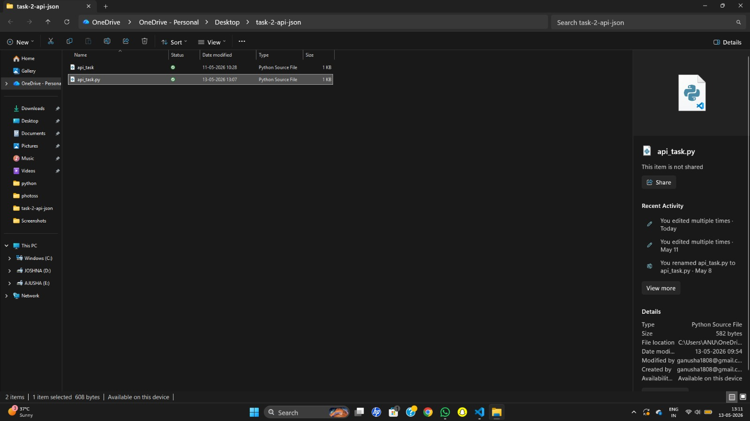
python_code.png
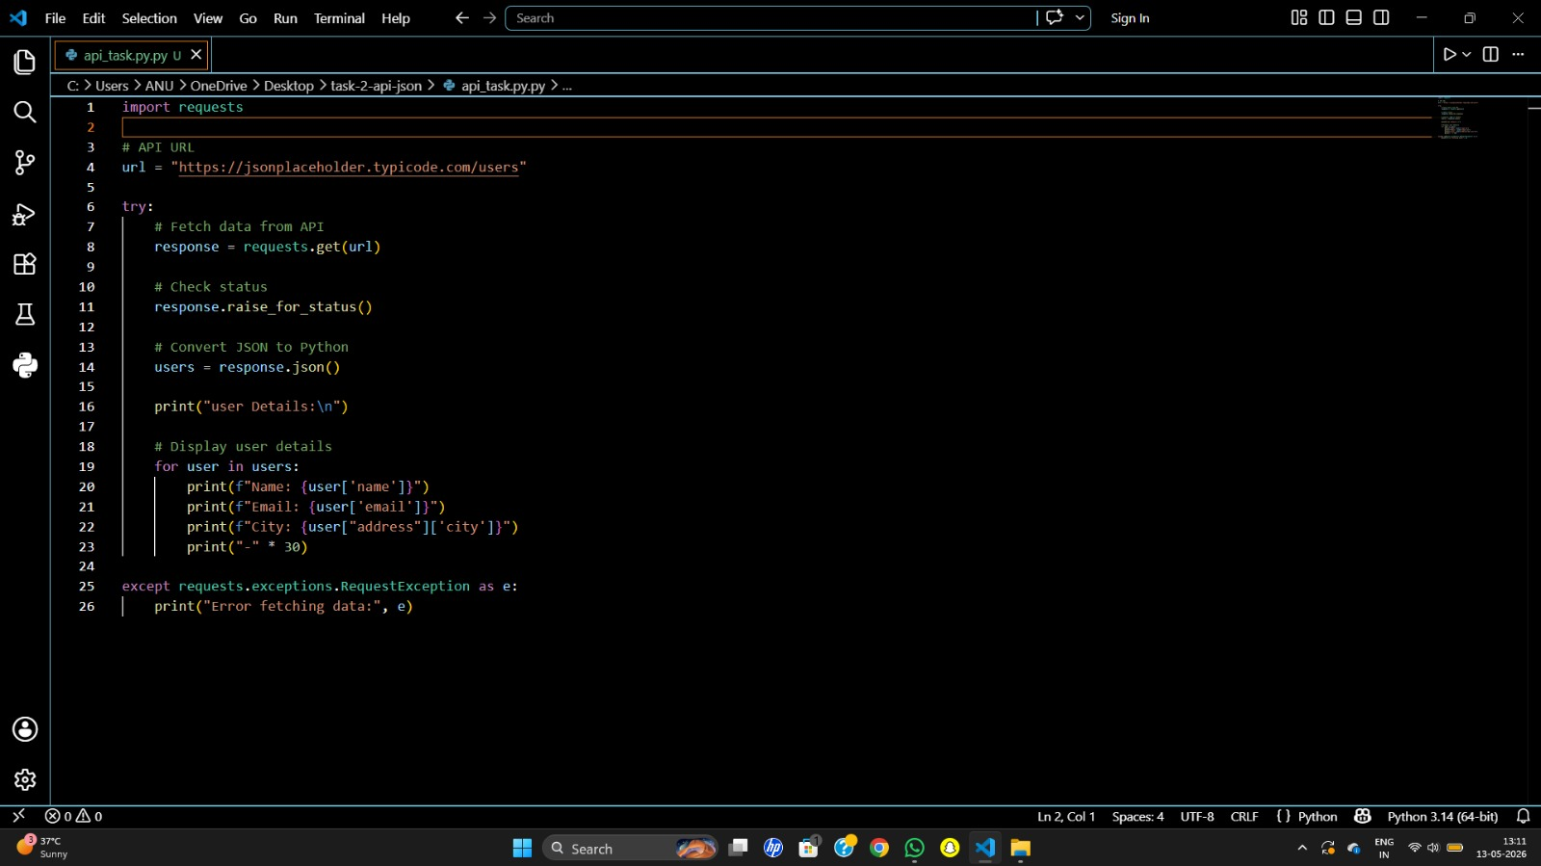
terminal_output.png
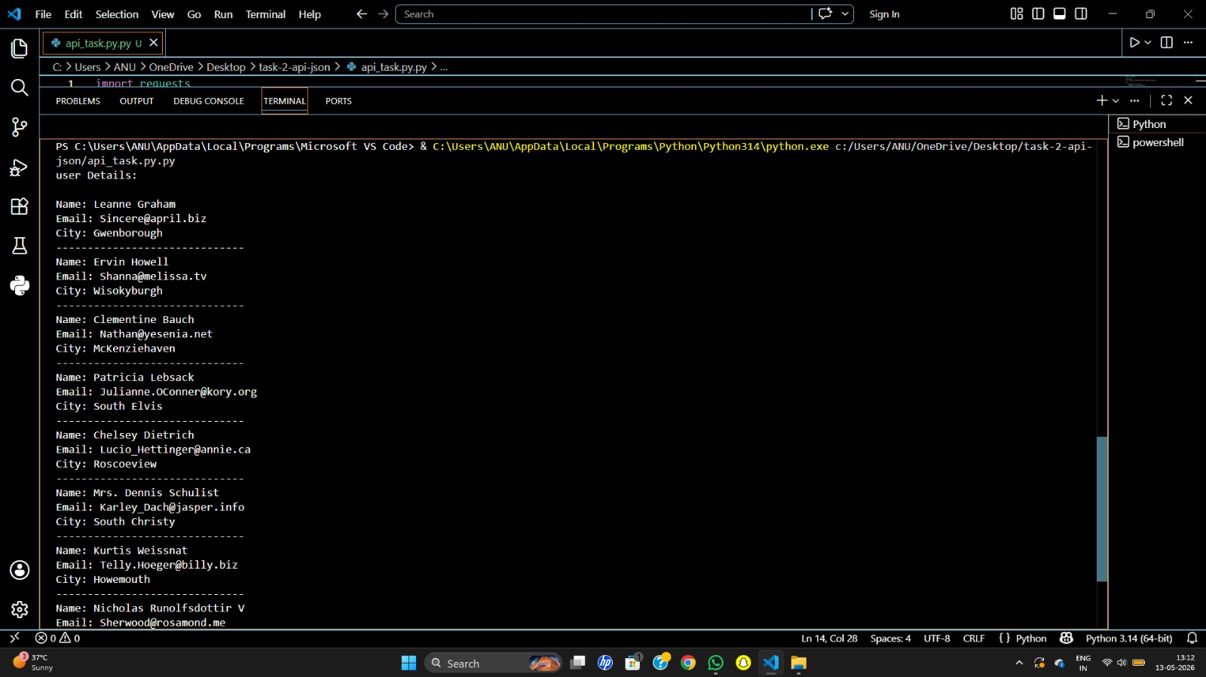
api_browser_output1.png
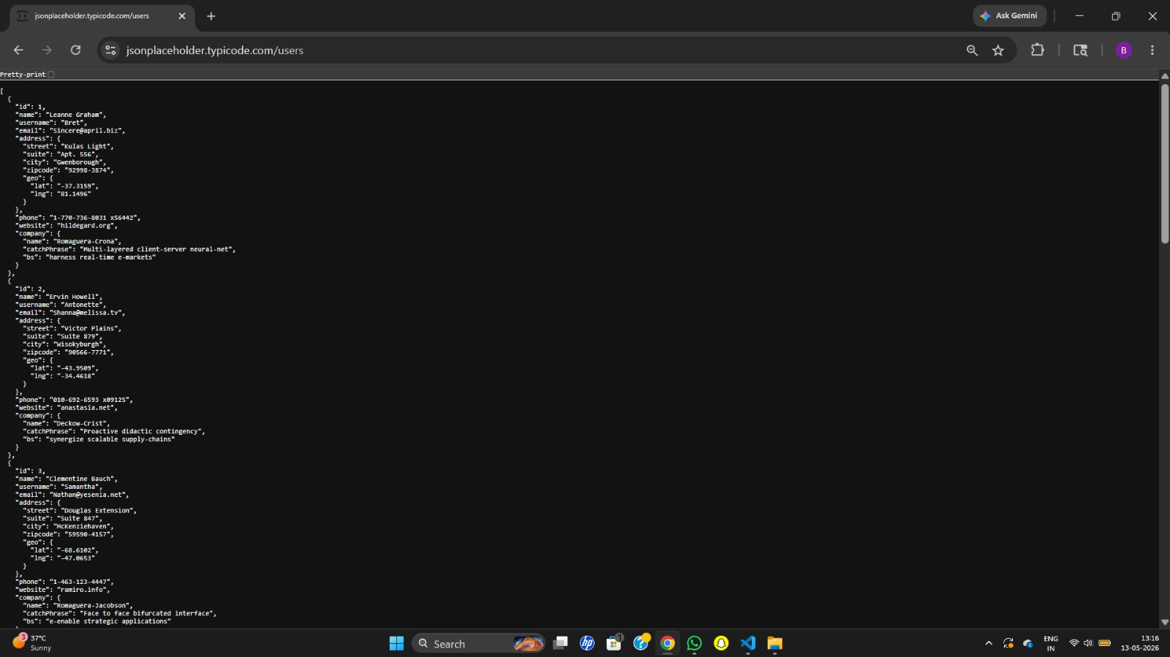
api_browser_output2.png
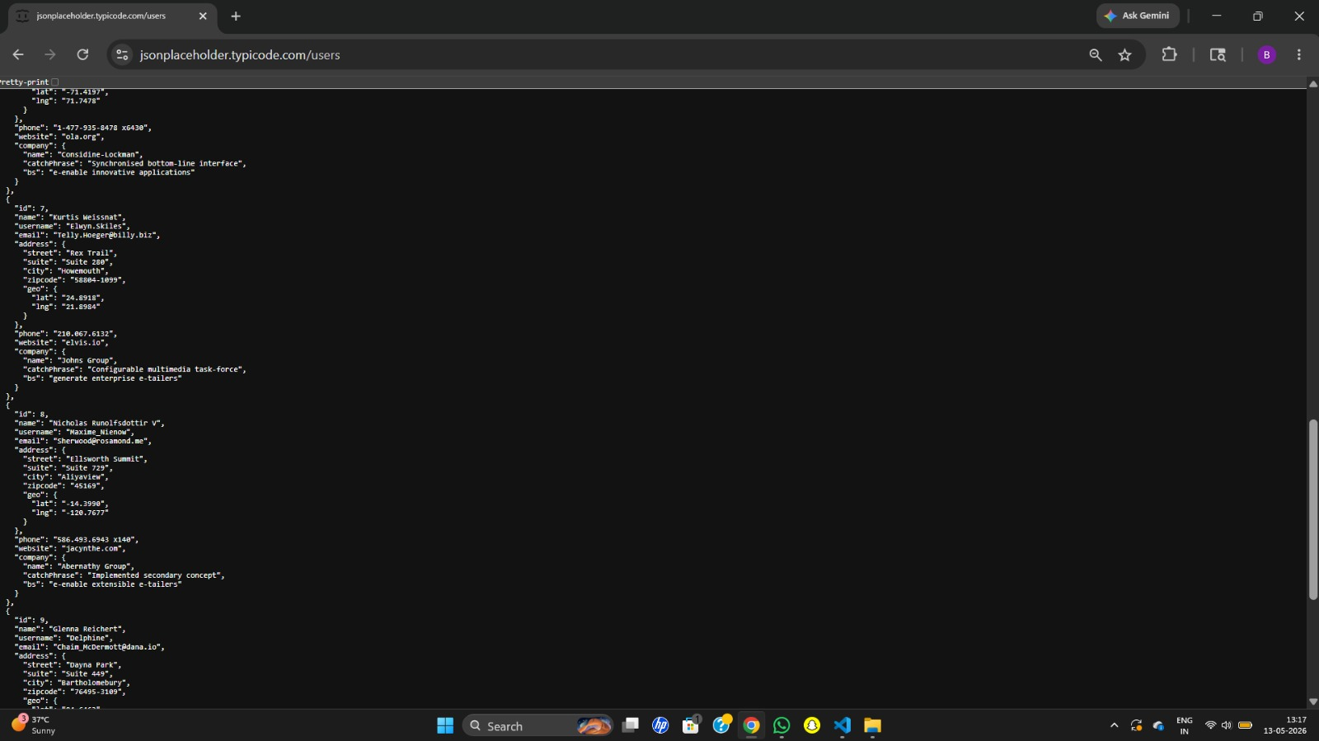

Learning Outcome
Learned how APIs work, how JSON data is handled in Python, and how to fetch and display data from external APIs.

Conclusion
Successfully completed Task 2 by integrating API using Python Requests library and handling JSON data.

